**Tic-Tac-Toe Game**

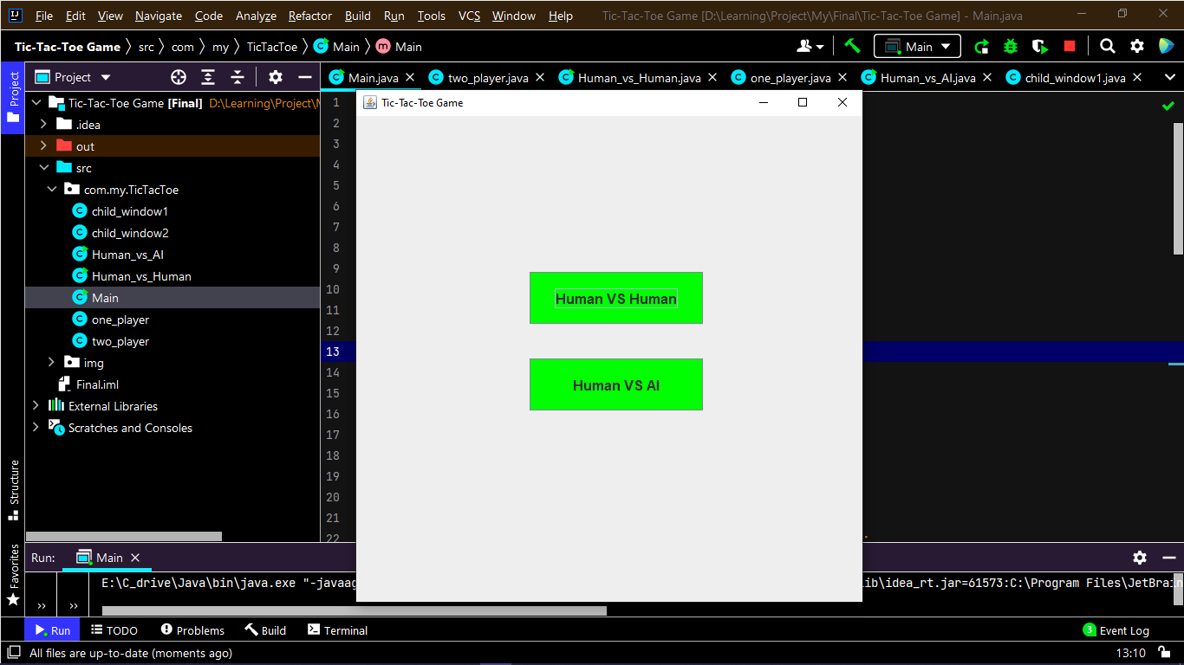

* **Human VS Human**

Simple logic

Player - 1

Player - 2

Player-1 VS Player-2

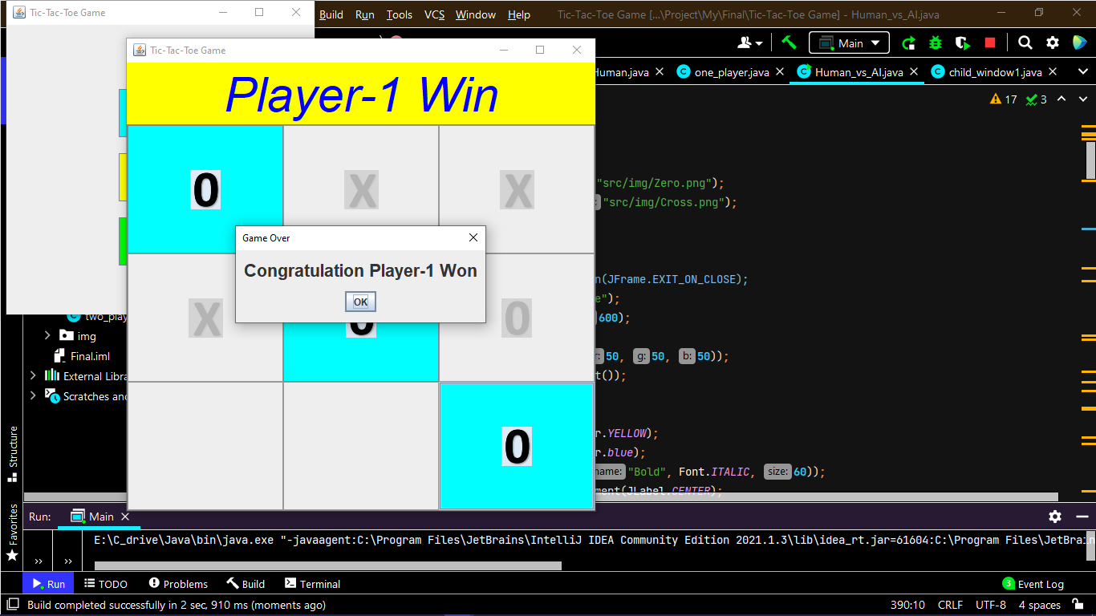

* **Human VS AI (System or CPU)**

Using minmax algorithm

Minimax is a decision rule used in [artificial intelligence](https://en.wikipedia.org/wiki/Artificial_intelligence" \o "Game theory), [decision theory](https://en.wikipedia.org/wiki/Decision_theory" \o "Decision theory), [game theory](https://en.wikipedia.org/wiki/Game_theory" \o "), [statistics](https://en.wikipedia.org/wiki/Statistics" \o "Statistics), and [philosophy](https://en.wikipedia.org/wiki/Philosophy" \o "Philosophy) for minimizing the possible [loss](https://en.wikipedia.org/wiki/Loss_function" \o "Loss function) for a [worst case (](https://en.wikipedia.org/wiki/Worst-case_scenario" \o "Worst-case scenario)*[max](https://en.wikipedia.org/wiki/Worst-case_scenario" \o "Worst-case scenario)*[imum loss) scenario](https://en.wikipedia.org/wiki/Worst-case_scenario" \o "Worst-case scenario).

When dealing with gains, it is referred to as "maximin"—to maximize the minimum gain. Originally formulated for n-player [zero-sum](https://en.wikipedia.org/wiki/Zero-sum" \o "Zero-sum) [game theory](https://en.wikipedia.org/wiki/Game_theory" \o "), covering both the cases where players take alternate moves and those where they make simultaneous moves, it has also been extended to more complex games and to general decision-making in the presence of uncertainty.

